Modern Slavery Policy

Overview and how we define Modern Slavery
Slavery, child labour and human trafficking are serious crimes and a violation of fundamental human rights. There are various forms of ‘Modern Slavery’ which deprives victims of their liberty and usually involves financial exploitation.
At Just Surveys Limited we conduct our business fairly, ethically and with respect to fundamental human rights. We are fully committed to the prevention of all forms of slavery, forced labour or servitude, child labour and human-trafficking, both in our business and in our supply chains. We will not tolerate it.
This policy does not form part of your contract of employment, and we reserve the right to amend this policy at any time.
You are required to read and comply with this policy if you work for, or on behalf of the Company in any capacity including as: an employee, director, officer, worker, consultant, volunteer, supplier or service provider.
Failure to comply with this policy may result in disciplinary action, including dismissal, or termination of the contract between you and the Company. It could also involve other legal steps being taken against you.
Preventing slavery and human-trafficking in our business
The Company makes appropriate checks on all employees, recruitment agencies and suppliers, to know who is working for, or on behalf of us.
The Company provides every employee with a written contract of employment. We pay every employee in accordance with the law. We comply with our legal obligations to ensure the health and safety of all our employees and workers, including in relation to working hours, rest breaks and holidays.
If you are an Employee or Worker providing services for us
You must immediately report any suspicions of Modern Slavery or human-trafficking in our business or supply chains to your supervisor. Your supervisor will investigate and report to the Managing Director, within a reasonable time, on actions which may require to be taken.
You will not suffer any detrimental treatment as a result of reporting any genuine concerns, raised in good faith, under this policy. This applies, even if after investigation, they are found to be mistaken. If you believe that you have suffered any such treatment, you should immediately inform Management and if you are an employee, refer to our Grievance and Whistleblowing Policies.

Just Surveys Limited will encourage the adoption of similar principles by its suppliers.

Signed

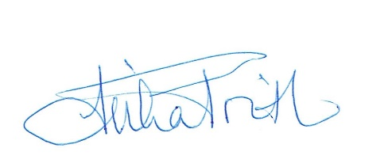

Reviewed 18/01/2024

